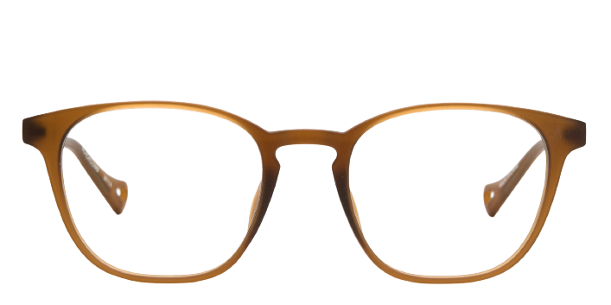 **Black comb**

Product information

|  |  |
| --- | --- |
| **Brands** | Kits |
| **Gender** | Unisex |
| **Lenses** | Prescription lenses included |
| **Material** | Eco Acetate |

Description

**Thoughtfully designed for an active lifestyle, the Blackcomb moves with you. Features include an ultra-lightweight and flexible acetate, gripped nose pads, and hingeless pins—all of the benefits, without the hassle. Whether you're going for a hike up the mountain, heading out for a city run or staying stylish in the boardroom, these classic and modern glasses are the perfect fit for the on-the-go lifestyle. Please note these frames fit large and are best suited to those with wider faces.**

|  |
| --- |
| What You’ll Get   * Thin and light tinted prescription lenses. * Soft case and cleaning cloth. * Unconditional 30 days return policy. Free return shipping. |